Jakob Drozd & Maddie Haynes

mhaynes@esri.com

Abstract

This document captures the details of the ArcGIS Online items used within the WFRC performance metric dashboard and key configuration points for future expansion and maintenance of the application

WFRC Performance metric dashboard

Contents

ArcGIS Online Components 2

**Layers** 2

**Maps** 2

**Apps** 2

Configuration Notes 3

**Experience Builder App Navigation** 3

**URL Parameters** 4

Dashboards 4

Experience Builder 6

**Button Configuration** 7

**Group Filter** 9

# ArcGIS Online Components

## **Layers**

|  |  |  |
| --- | --- | --- |
| Item Name | Item ID | Source |
| WFRC_PerformanceMetrics | 14bf54631b1047cbaead2c53346a1ad9 | Python notebook |
| WFRC_PerformanceMetricBoundaries | 98bfc2eb26d94adcb6ae9cab2f7d57a8 | ArcGIS Pro |
| Access To Opportunities (Workplace ATO, TAZ Based) | d485928e777740c7963a5b68a37db116 | WFRC |
| Population_TAZ_Projections_RTP_2023 | db1ebf9044e347758468de2b6d5f744a | WFRC |
| Household_TAZ_Projections_RTP_2023 | 920e71114c8e491cb0d1c01e3766d839 | WFRC |

## **Maps**

|  |  |  |
| --- | --- | --- |
| Item Name | Item ID | Layers Included |
| ATO Job Auto | c834527d4d1544a088d0ad1ac0b8b869 | Access To Opportunities symbolized by Access to Jobs by Auto (duplicated for cartographic purposes) |
| ATO Job Transit | fdcb155bb5b146e1b940d36cb5525c7e | Access To Opportunities symbolized by Access to Jobs by Transit (duplicated for cartographic purposes) |
| Pop Projections | 06003f5b4779403d8bf8af3af02fe7cf | Population_TAZ_Projections_RTP_2023 symbolized by 2023 to 2050 % growth (duplicated for cartographic purposes) |
| HH Projections | 5bb58295a1d44ceca1da28f3332afc6e | Household_TAZ_Projections_RTP_2023 symbolized by 2023 to 2050 % growth (duplicated for cartographic purposes) |

## **Apps**

|  |  |  |  |  |
| --- | --- | --- | --- | --- |
| Item Name | Item ID | App Type | Purpose/Location | Powering Data Source |
| WFRC Metrics Dashboard | 41b9929c16674ec3825cd2b0863765d9 | Experience Builder | Main app | WFRC_PerformanceMetrics |
| WFRC Tier 1 Dashboard – Jobs by Auto | 2800bfe0bb7d4fd58b5649597bbd3f32 | Dashboard | “Big 5” Metric #1 – App homepage | WFRC_PerformanceMetrics |
| WFRC Tier 1 Dashboard – Metric 2 | 21e116cb8f88492b9093b440caf84491 | Dashboard | “Big 5” Metric #2 (empty) – App homepage | WFRC_PerformanceMetrics |
| WFRC Tier 1 Dashboard – Metric 3 | ad30a3f877014d509796262d6f2a4e83 | Dashboard | “Big 5” Metric #3 (empty) – App homepage | WFRC_PerformanceMetrics |
| WFRC Tier 1 Dashboard – Metric 4 | 97e80d0cd00b474c93c6c82a0fba0f04 | Dashboard | “Big 5” Metric #4 (empty) – App homepage | WFRC_PerformanceMetrics |
| WFRC Tier 1 Dashboard – Metric 5 | 281bab4fe149443b9bec501df7f8a849 | Dashboard | “Big 5” Metric #5 (empty) – App homepage | WFRC_PerformanceMetrics |
| WFRC Tier 2 Dashboard - Jobs by Auto | 3f600338bc01491680da03f743efbc7d | Dashboard | Tier 2 – line graph view | WFRC_PerformanceMetrics |
| WFRC Secondary Dashboard - Jobs by Transit | bfb3dab401a0418b8f7acebfb18ebc99 | Dashboard | Related Metrics section – bar chart | WFRC_PerformanceMetrics |
| WFRC Population Projections Dashboard | 66ddf88da25048caaf3096ca1ba7a98d | Dashboard | Related Metrics section – line graph | WFRC_PerformanceMetrics |
| WFRC Household Projections Dashboard | b343bc22ffc7497a8416c0e07de3cfdf | Dashboard | Related Metrics section – line graph | WFRC_PerformanceMetrics |

# Configuration Notes

## **Experience Builder App Navigation**

The application is structured as a collection of 9 Views. These Views can be thought of as the “pages” of the application, with one view for the homepage with the Big 5 Metrics, one view for the ATO: Jobs by Auto detailed bar chart, etc. Views are edited and reordered using the Section widget. To add a View for the bar chart breakdown for Big 5 Metric #2, for example, you would add a new View in the Section widget interface:

Each View consists of a variety of layout widgets, page elements, and map/data-centric widgets. A View’s structure can be seen on the page tab in the Outline section on the left side of the editing interface:

The content of the application is supplied primarily by Map and Embed widgets. Dashboards are brought in to the app via URL using the embed widget.

## **URL Parameters**

### Dashboards

Each dashboard embedded in the application must have URL parameters configured within the dashboard edit interface. To access URL parameters, click the View button in the toolbar -> Settings -> Edit URL parameters:

In the popup interface, choose a parameter type for a new URL parameter. The URL parameter configured for the geography field (GeoName), for example, is categorical.

In the next interface, specify the name, data type, operator, and filter targets for the parameter. The name given to the parameter here will need to be entered exactly later on in the Experience Builder URL parameter configuration. In the filter section, choose which dashboard elements will need to change when the user selects a new geography. For this example, with the Tier 1 Jobs by Auto dashboard, this includes the indicator for total jobs, the bar chart, and the indicator for percent change from 2023 to 2050. Lastly, specify the source/target field relationship between the URL parameter and the chosen elements. The source field in this example is the name of the URL parameter (geoname), and the target field is the underlying dataset’s geography field (GeoName).

### Experience Builder

In order to dynamically update the dashboards throughout the application, the applications are embedded with a dynamic URL to resolve the URL parameter upon selection. To do this, connect the embed widget to a data source, specifically the performance metrics layer generated by the python script, paste the URL to the dashboard with the URL parameter expression, and then insert the field used to resolve the URL.

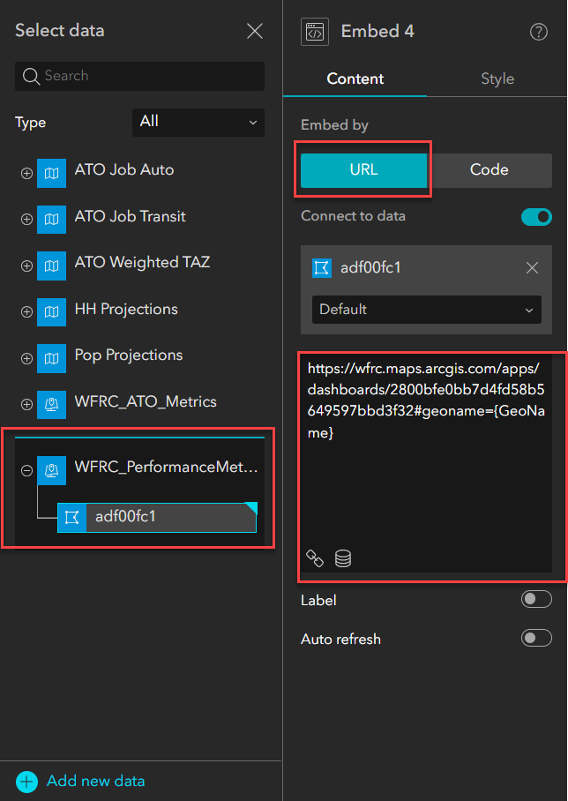

Importantly, when inserting the field the value must be changed from ‘Selected’ to ‘Default’.

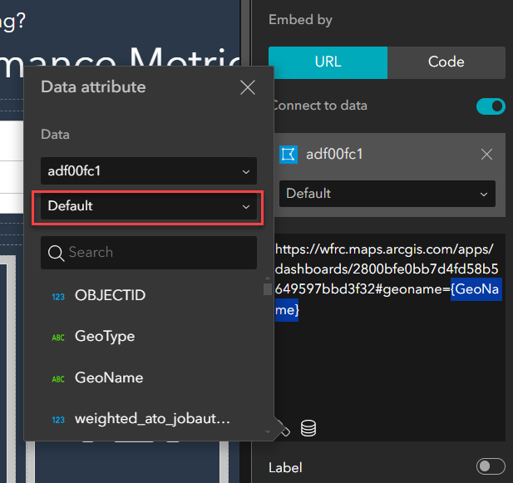

## **Button Configuration**

Buttons in Experience Builder can be configured to link to other locations within the application or to an external URL. You also have the control of whether the location should be opened in the app window, current window, or new window.

The application is currently configured to only link to other views within the app.

Buttons can be rounded in the “border radius” parameter of the configuration panel. Larger values will return a more rounded appearance.

## **Group Filter**

The list of eligible geographies is controlled by the filter widget. Geographies display in alphabetical order, but the Wasatch Front Regional Council Region is set as the default. The default display and additional geographies, as well as the display name of any geographies, can be modified by opening the filter configuration and modifying the SQL expression:

In order to zoom the maps, the map data source needs to be added as a data source in the filter widget. To do this, simply click ‘Select data’ and select the feature layer in the map that is being added (note, be sure to select the top-level layer, not the background layer used for cartographic purposes).

Once added, the data source should be added within the filter widget to filter on any of the City, Small Area, County (or other geoname) fields using the OR operator.

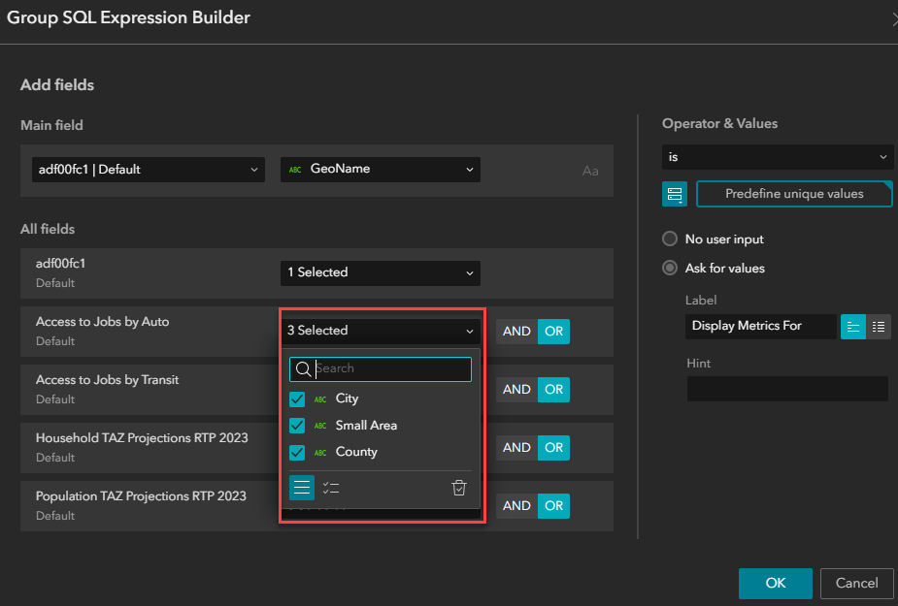

Lastly, an action should be configured to both zoom and pan to the map with only the primary performance metrics layer and map layer as triggers. Example shown below for ATO Job Auto: A screenshot of a computer
